Capstone Project – DevOps

**To do-**

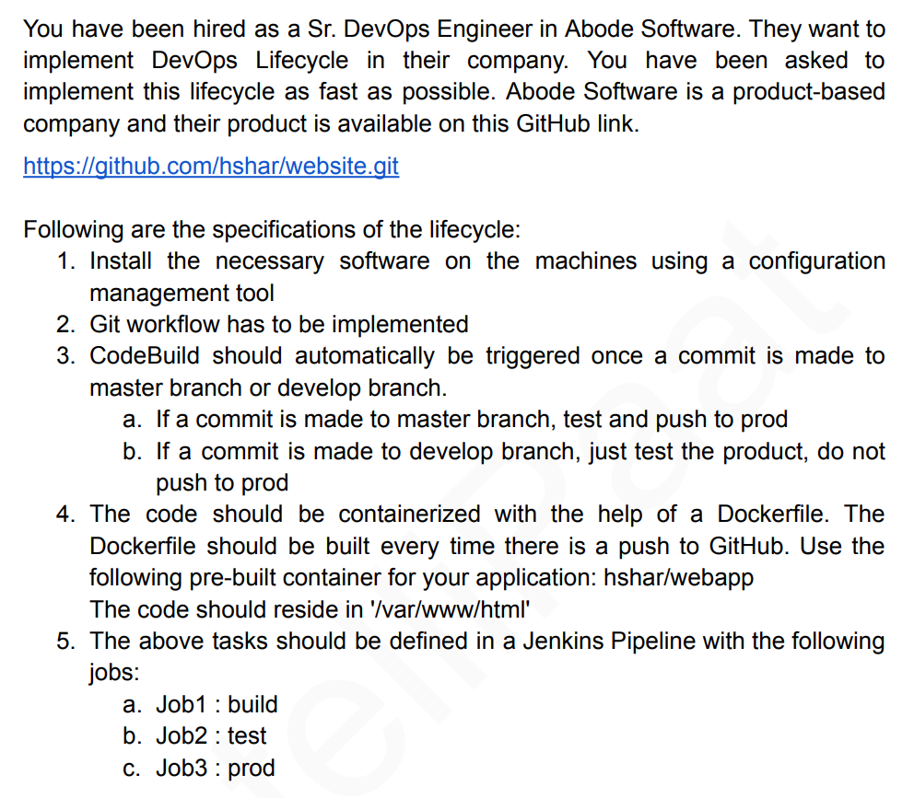

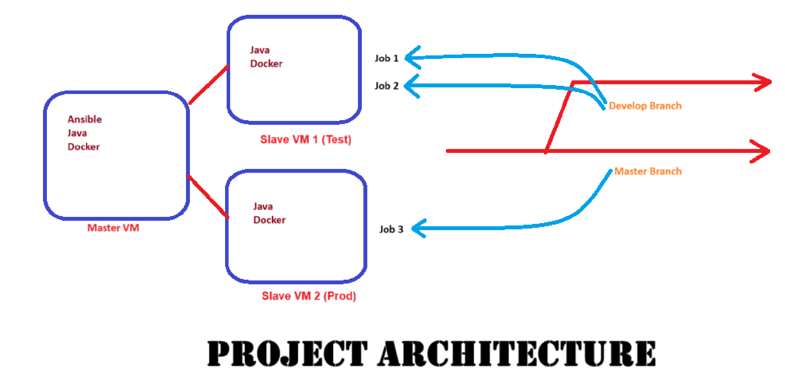

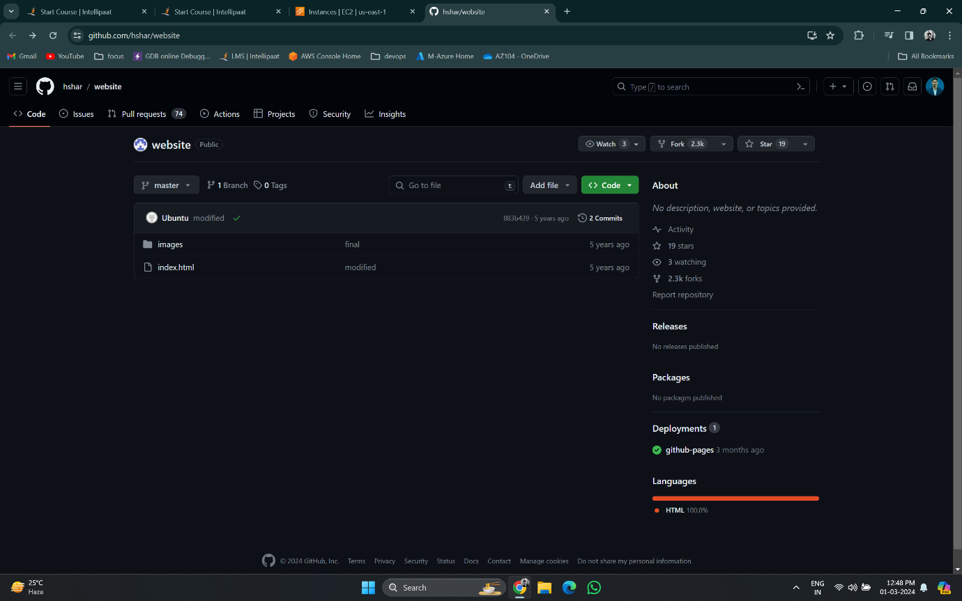

**Github Website**

<https://github.com/hshar/website>

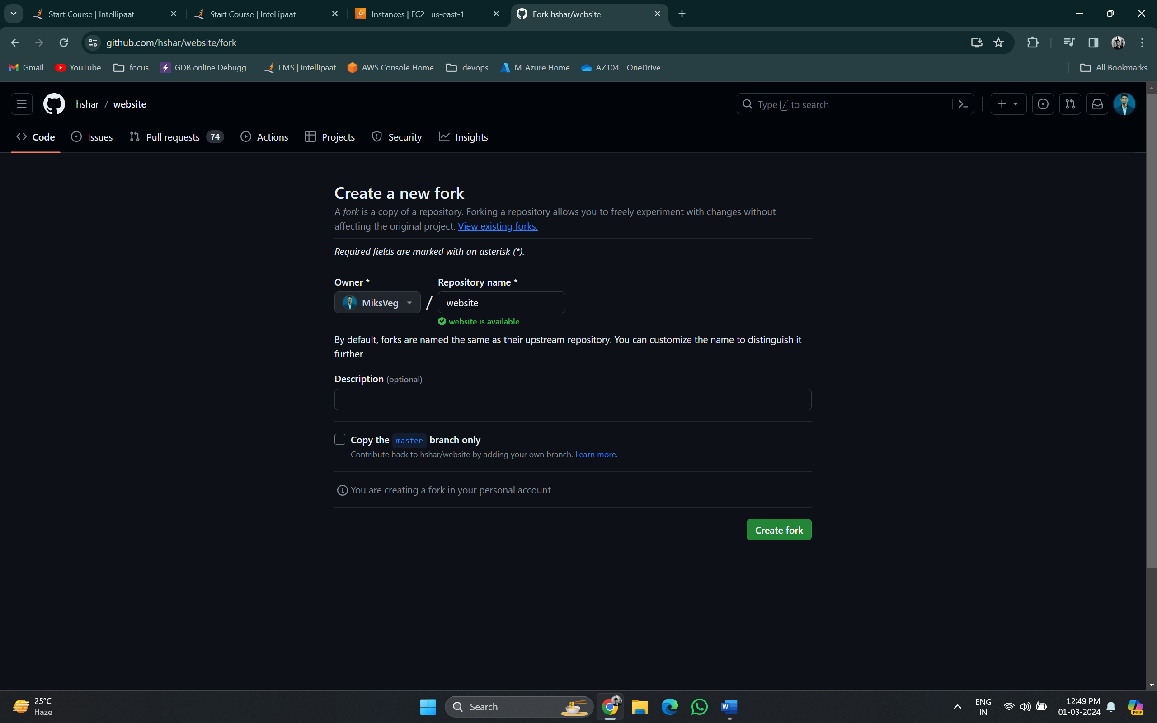

Forking from <https://github.com/hshar/website>

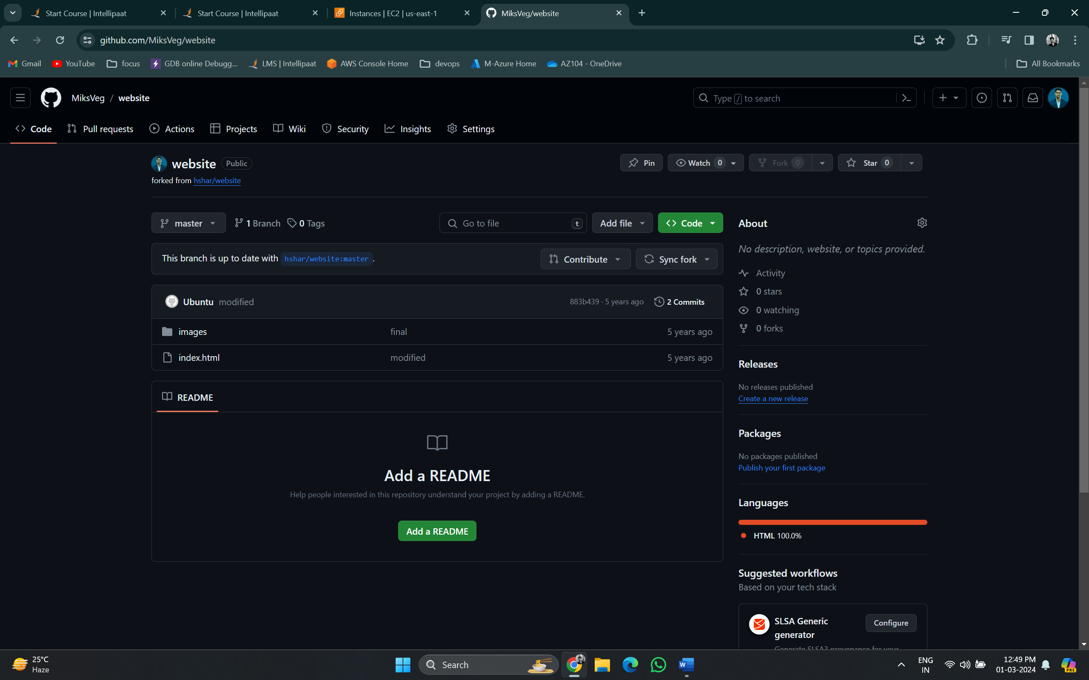

Forked successfully from <https://github.com/hshar/website>

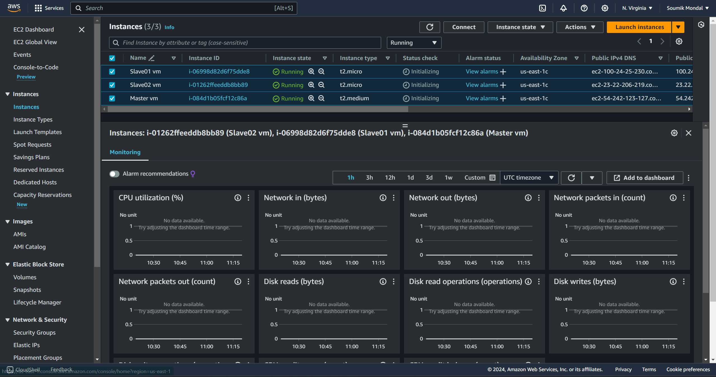

Created 3 virtual machines in AWS in North Virginia region

Logged in to the Master Vm and create a script

**Install.sh** – for ansible install

sudo apt update

sudo apt install software-properties-common -y

sudo add-apt-repository --yes --update ppa:ansible/ansible

sudo apt install ansible -y

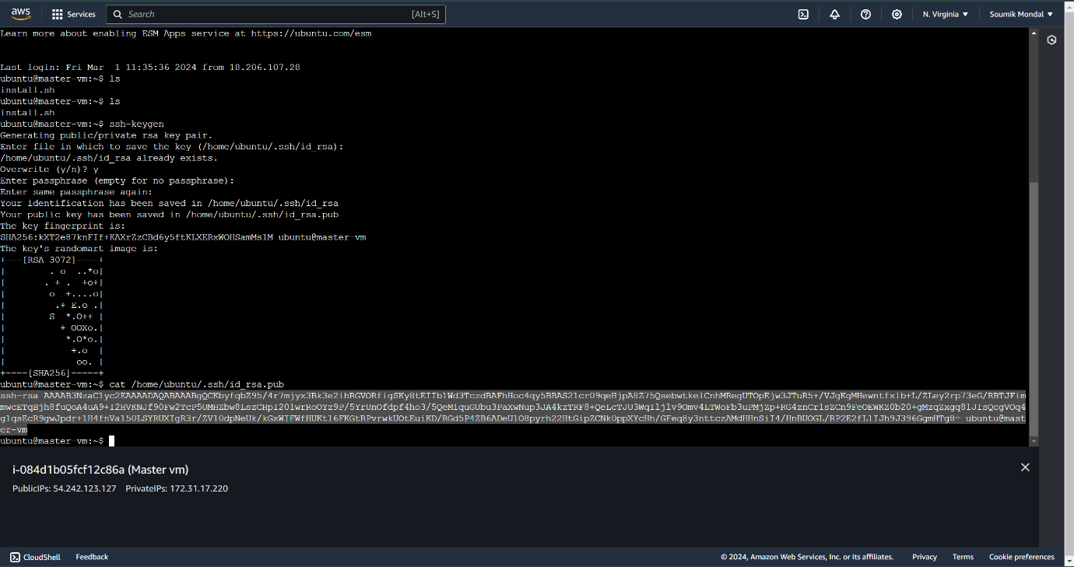

ssh-keygen



After installing ansible create and copied the ssh key from master vm

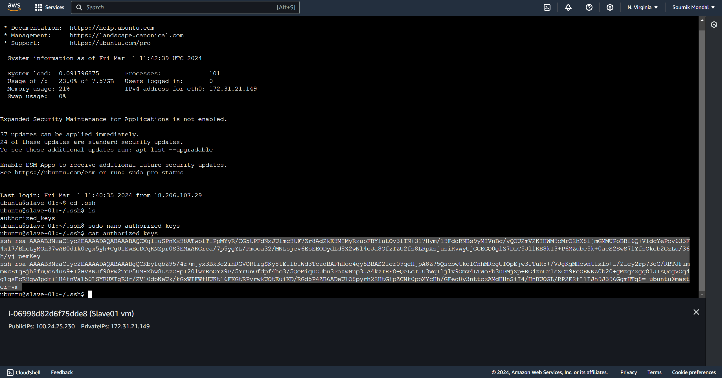

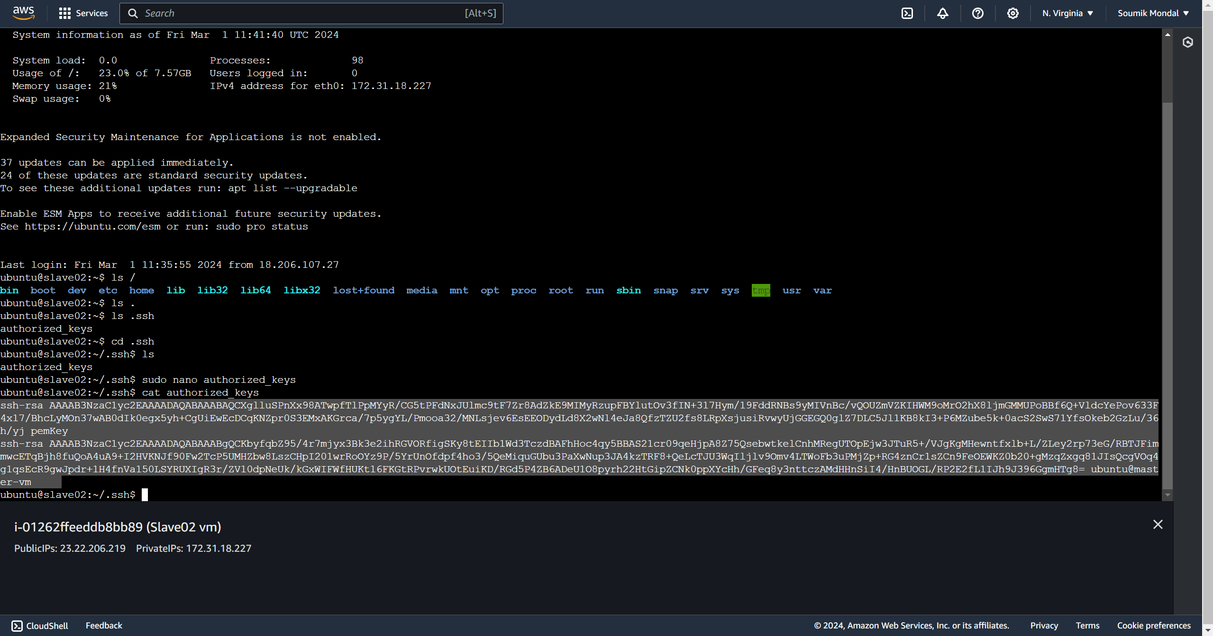

Pasted the key in [.ssh/authorized_keys] path in both vms

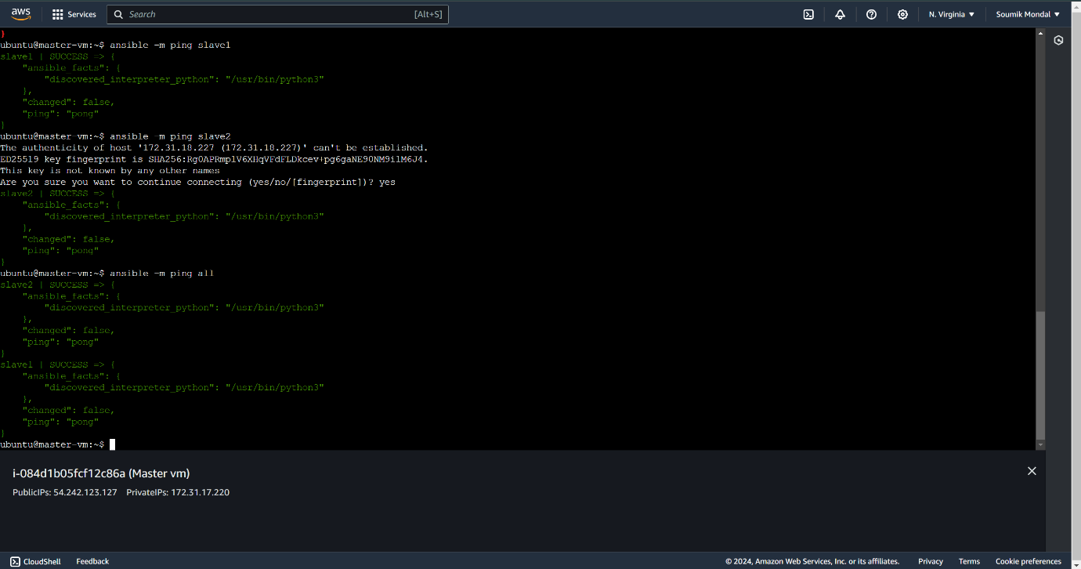

ansible -m ping all



Checking connection check for slave1 vm and slave2 vm is successful from Master vm

**master_task.sh –** Task for master vm [ java, Jenkins, and docker installation]

sudo apt-get update

sudo apt-get install docker.io -y

sudo apt-get install openjdk-11-jdk -y

sudo wget -O /usr/share/keyrings/jenkins-keyring.asc \

  https://pkg.jenkins.io/debian/jenkins.io-2023.key

echo deb [signed-by=/usr/share/keyrings/jenkins-keyring.asc] \

  https://pkg.jenkins.io/debian binary/ | sudo tee \

  /etc/apt/sources.list.d/jenkins.list > /dev/null

sudo apt-get update

sudo apt-get install jenkins -y

**slave_task.sh -** Task for slave vms [ java, and docker installation]

sudo apt-get update

sudo apt-get install docker.io -y

sudo apt-get install openjdk-11-jdk -y

**play.yaml -** Creating a playbook for ansible to run **master_task.sh** and **slave_task.sh**

---

- hosts: localhost

  become: true

  name: installing jenkins, java and docker

  tasks:

  - name: Tasks for our Master

    script: master_task.sh

- hosts: slave1

  become: true

  name: installing java and docker

  tasks:

  - name: Tasks for our test

    script: slave_task.sh

- hosts: slave2

  become: true

  name: installing java and docker

  tasks:

  - name: Tasks for our prod

    script: slave_task.sh

Created master_task.sh slave_task.sh and play.yaml files in the master vm

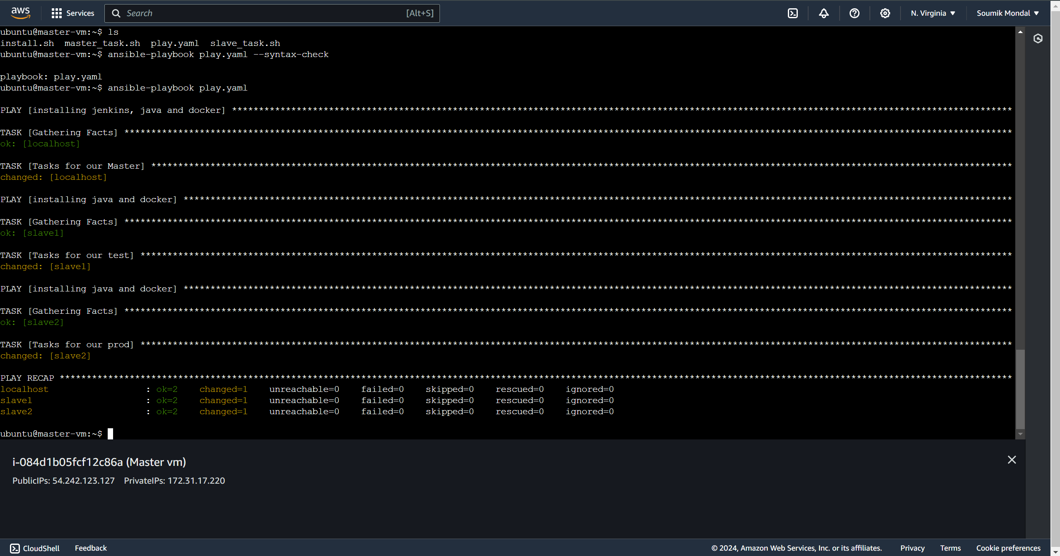



Ansible-playbook play.yaml

Successfully run **play.yaml** file

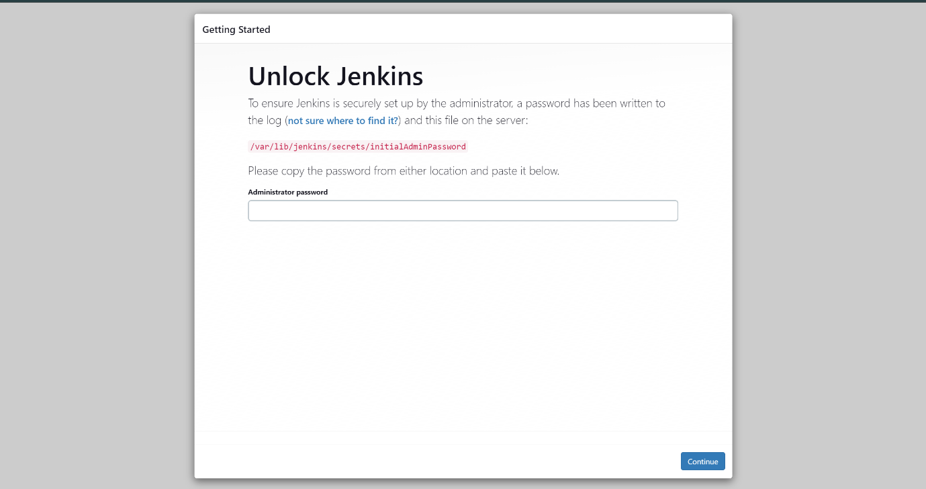

<Master vm IP>:8080 – to access Jenkins portal

Jenkins running successfully

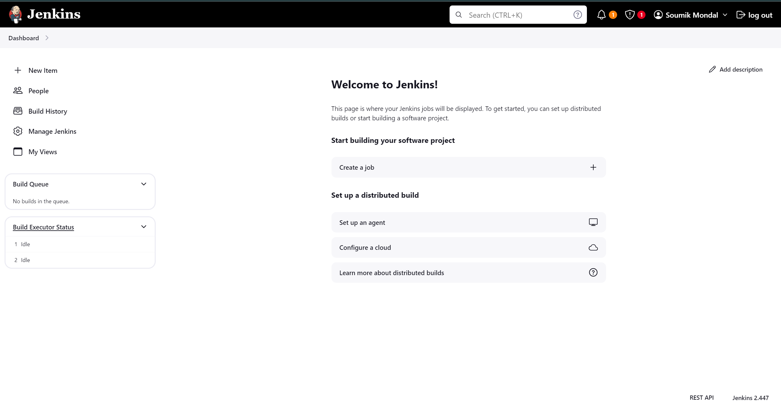

Access **/var/lib/jenkins/secrets/initialAdminPassword** for the pass key in Master vm and log in to Jenkins

**Dockerfile -**

FROM hshar/webapp

RUN apt update

ADD . var/www/html

ENTRYPOINT apachectl -D FOREGROUND

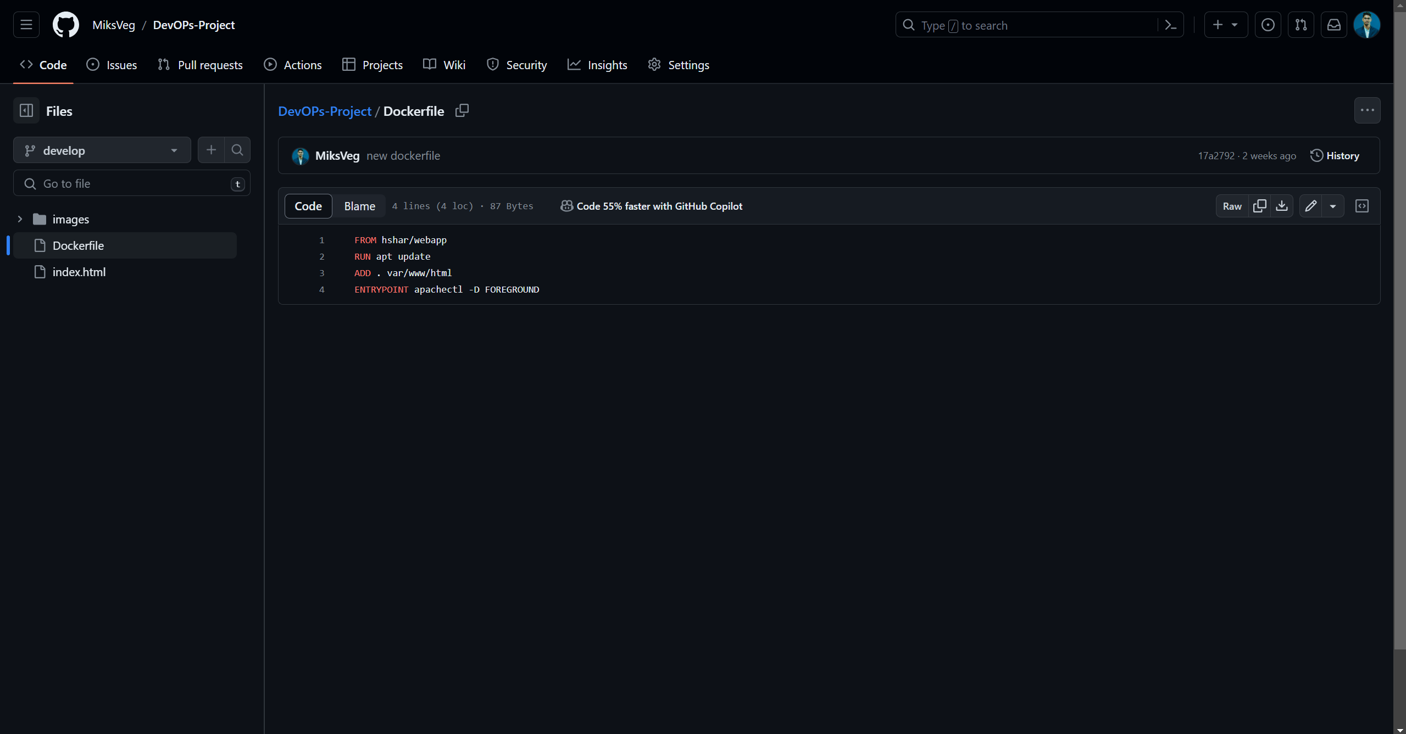

Created the **Dockerfile** in GitHub repo

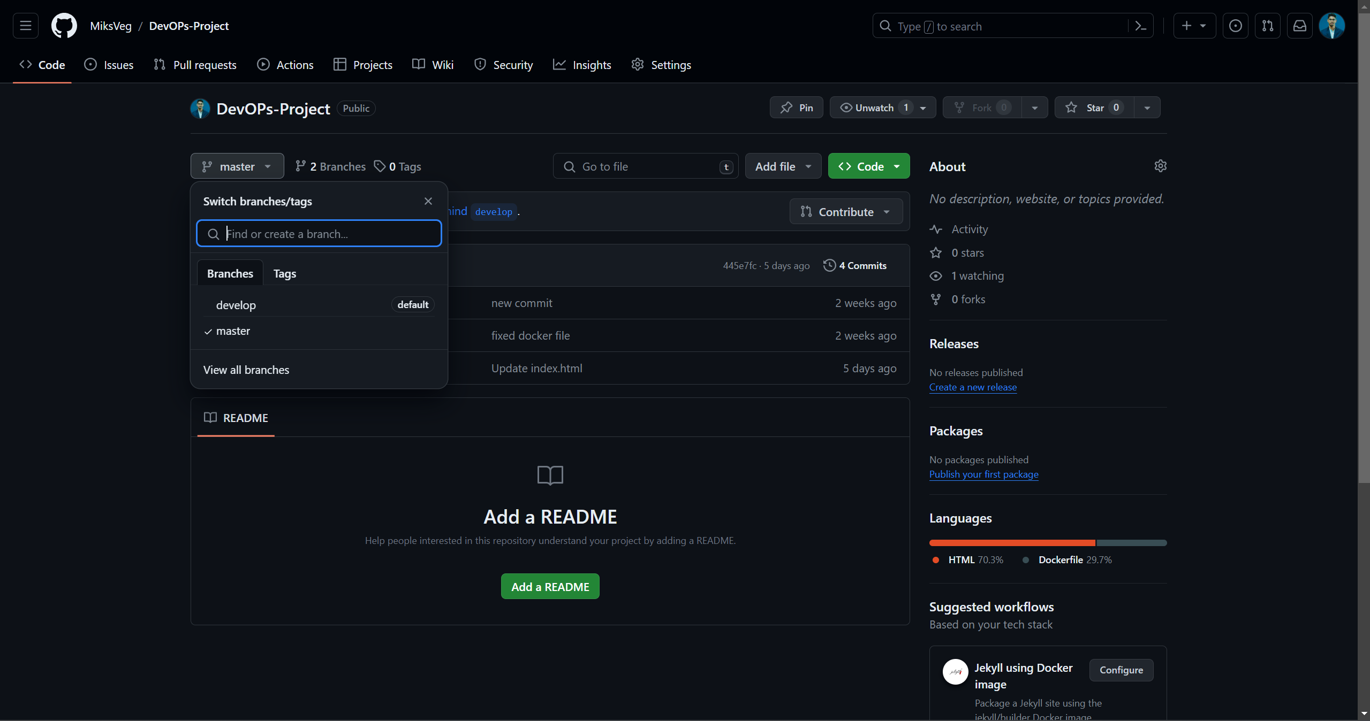

Create the same **master branch** and **develop branch** to the GitHub repo

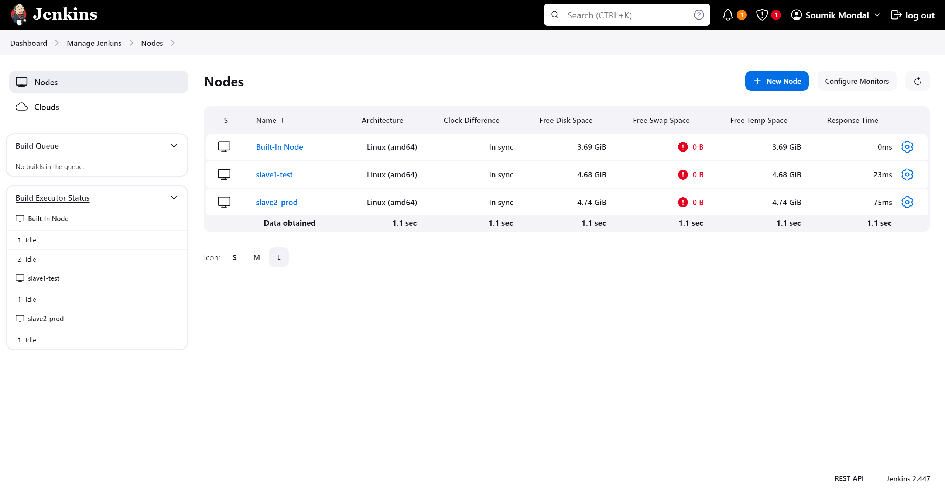

Connected Jenkins with test and prod node

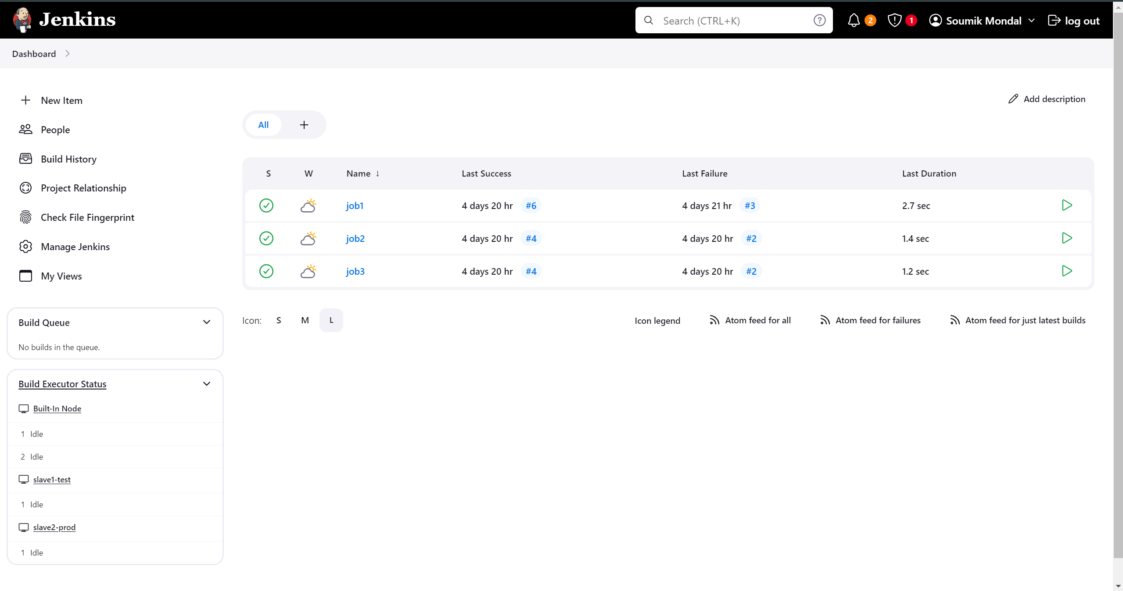

Created 3 jobs [ **job1, job2, and job3**]

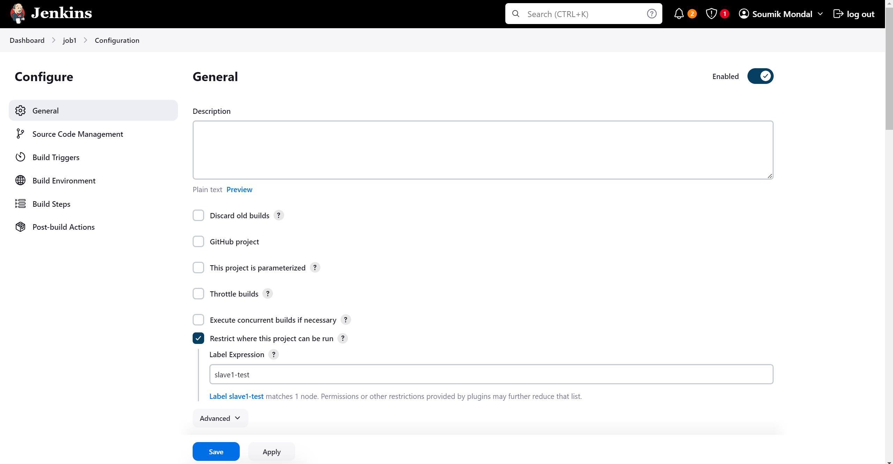 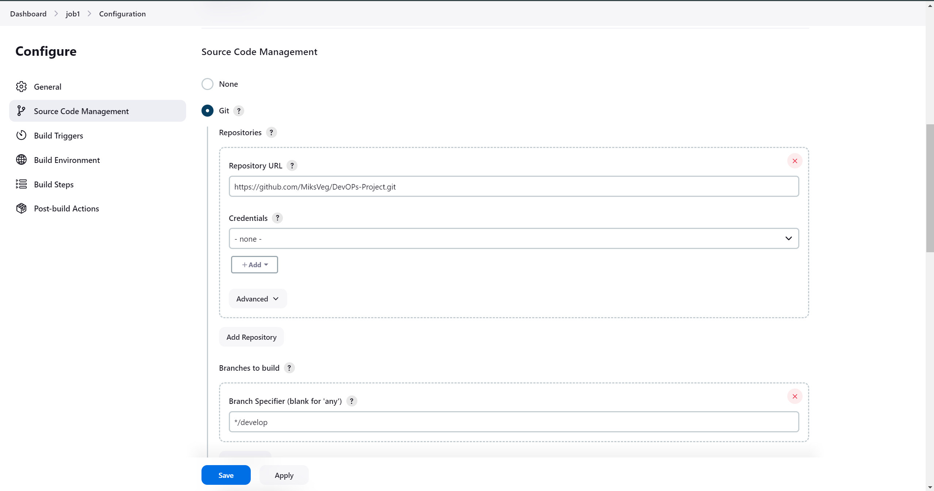 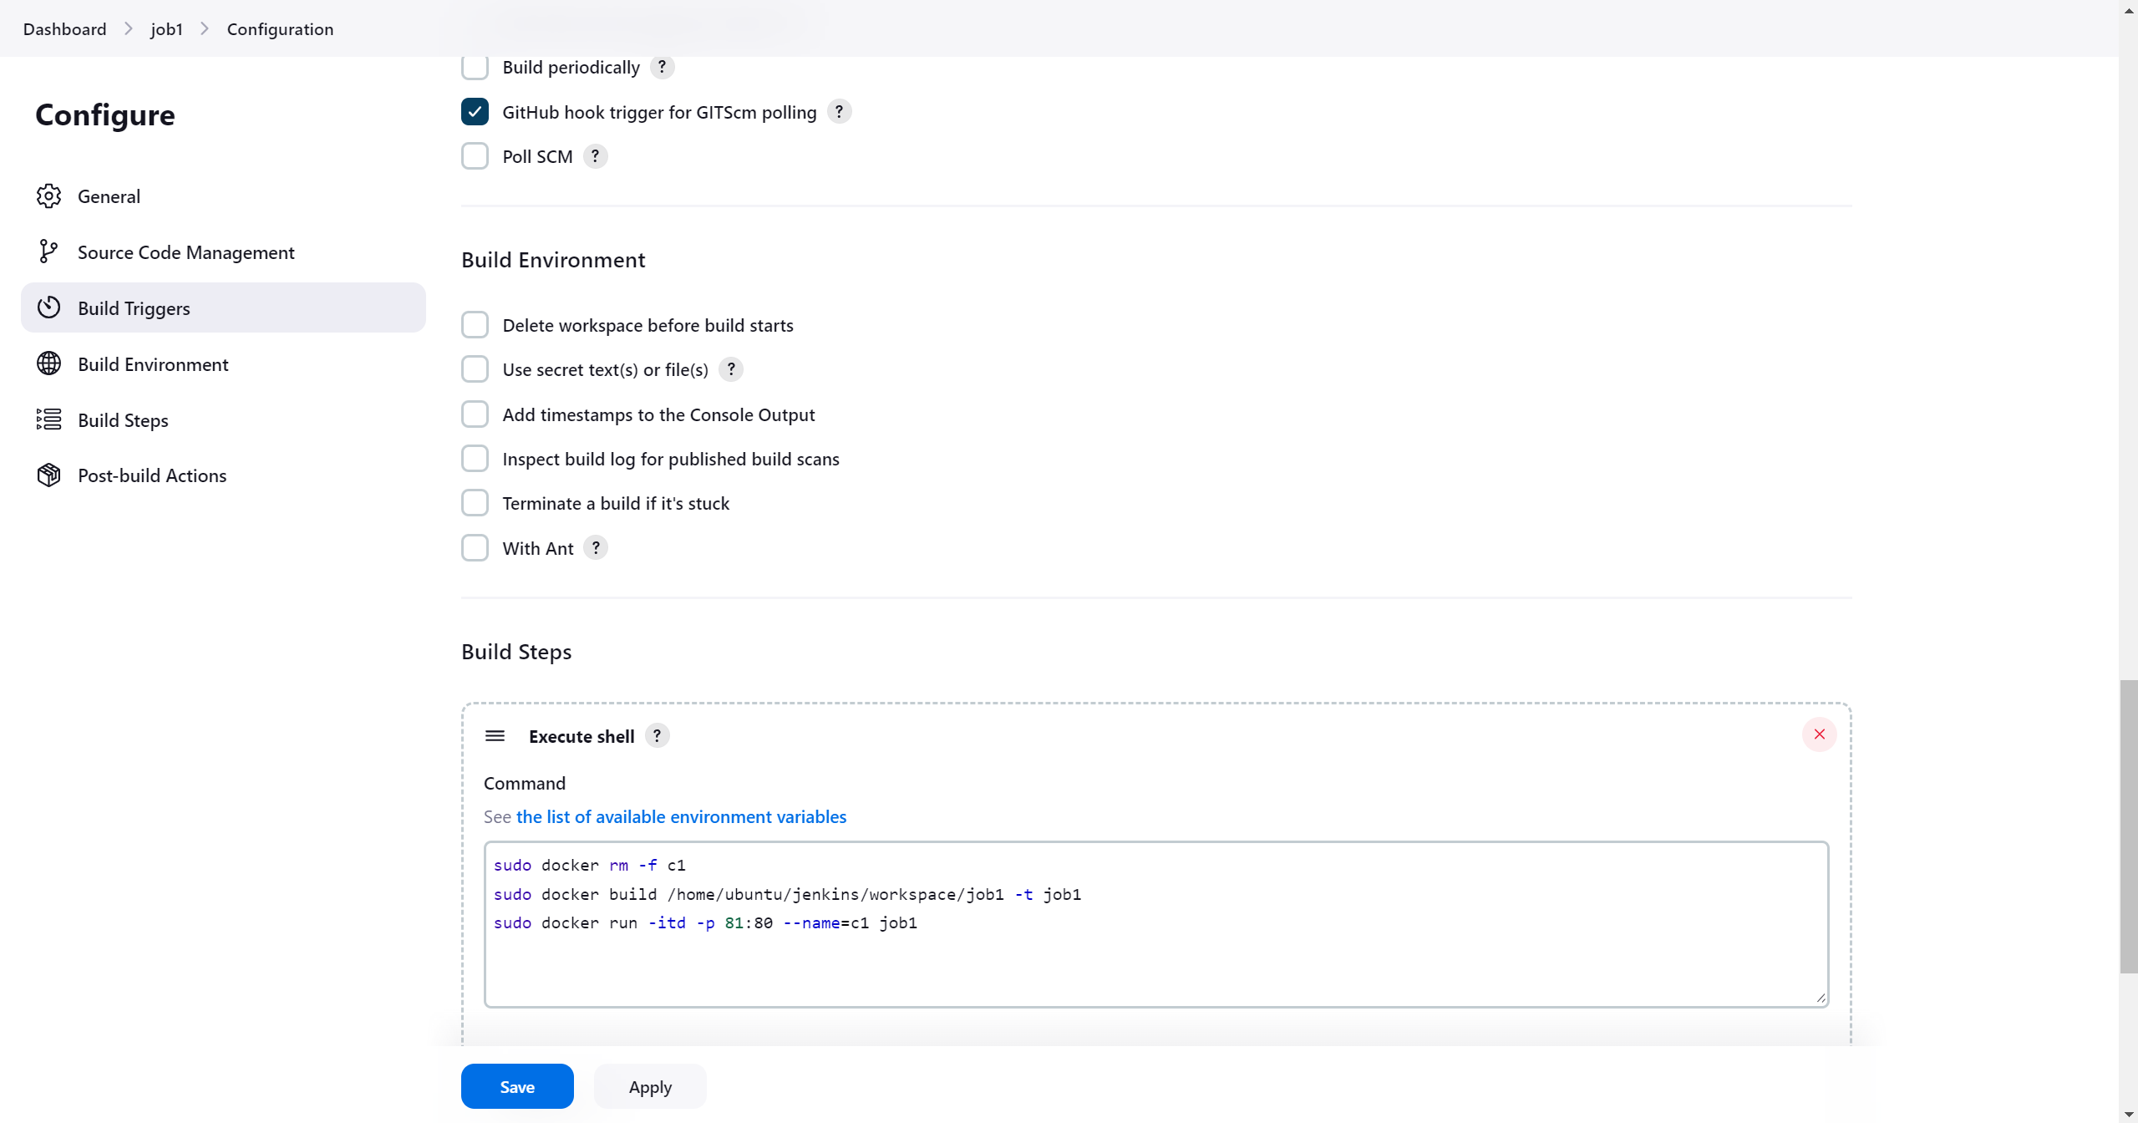

Job1 configurations

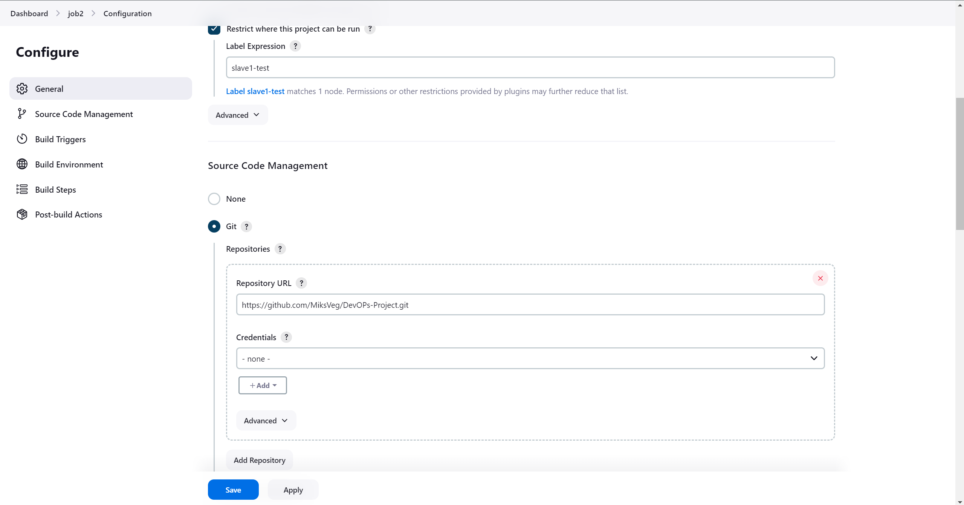 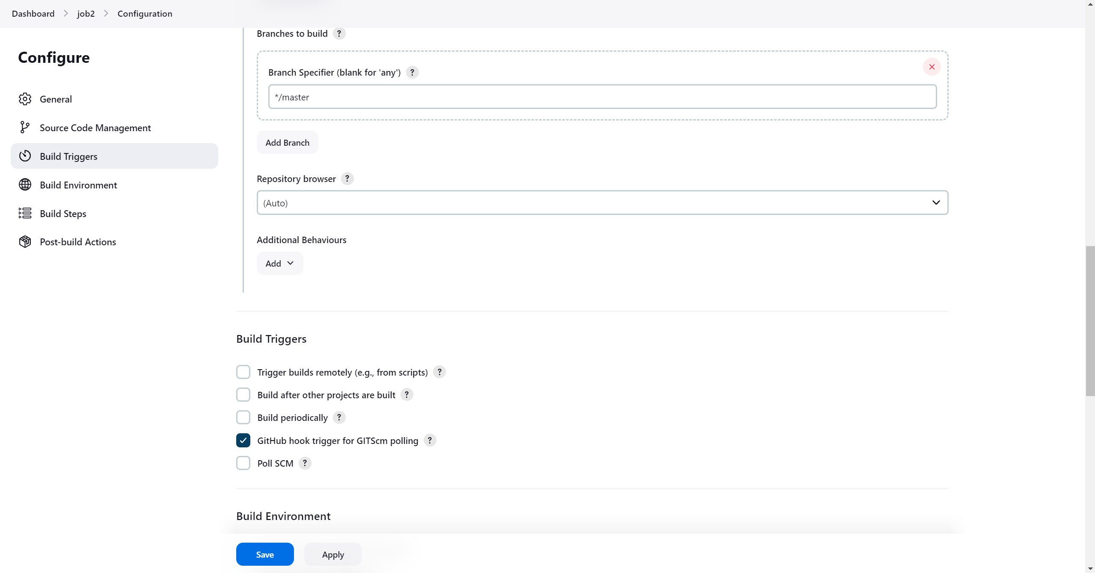 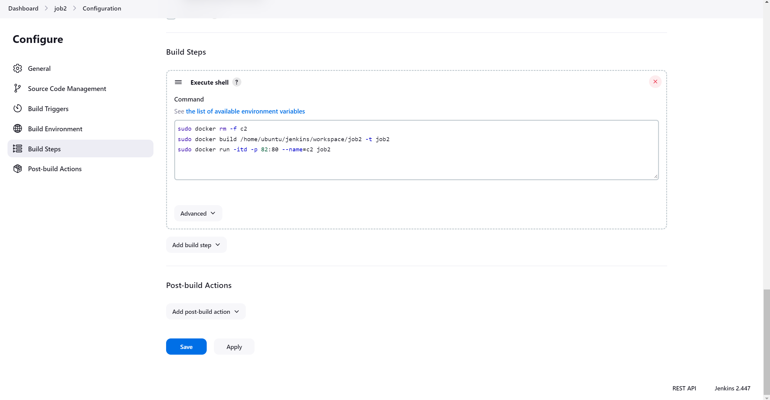

Job2 configurations

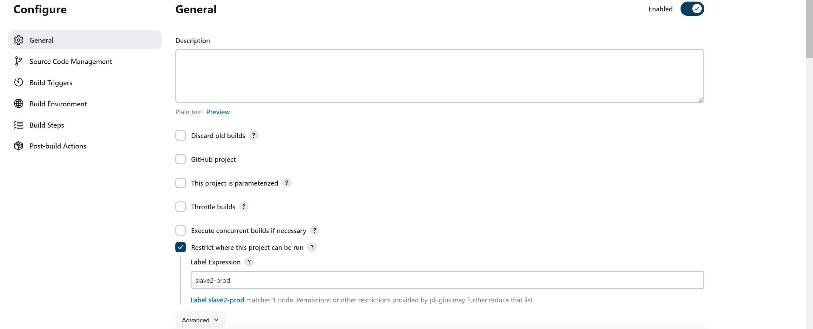 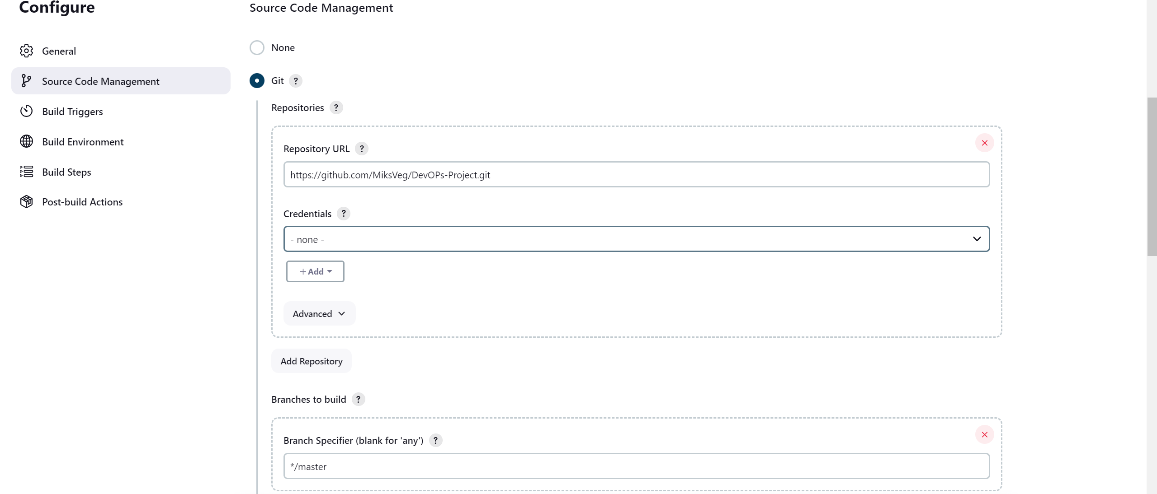 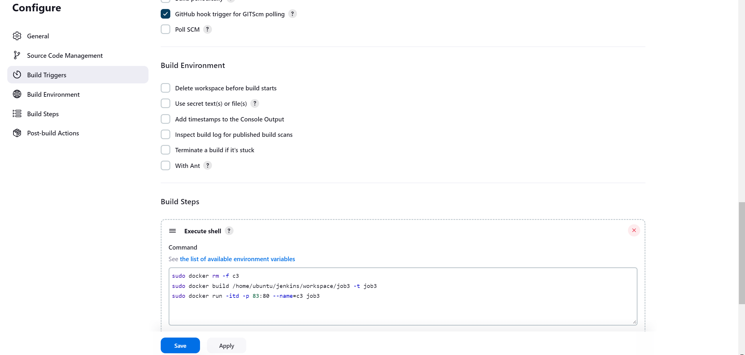

Job3 configurations

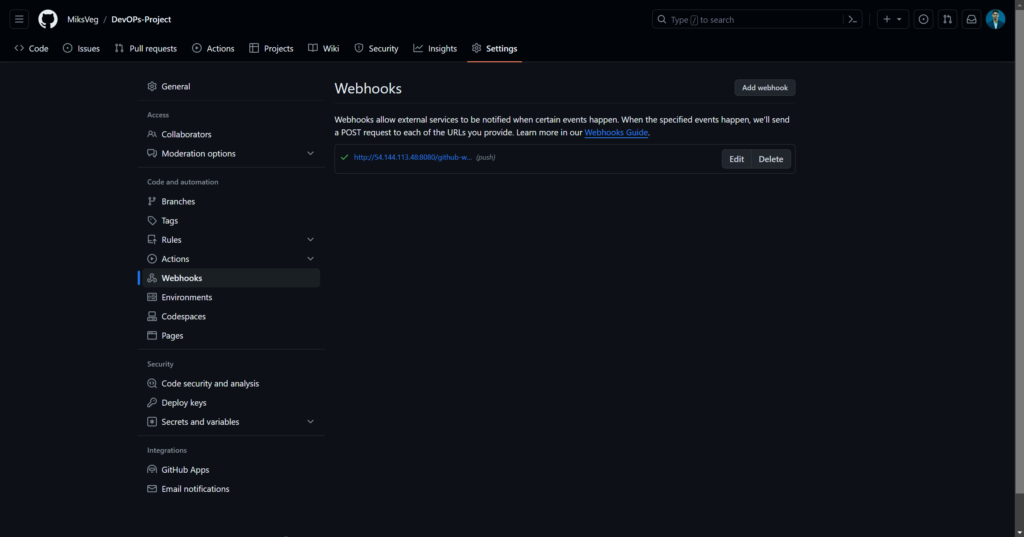

Webhook implementation

**--------------------------------We have completed with all the configurations-------------------------------**

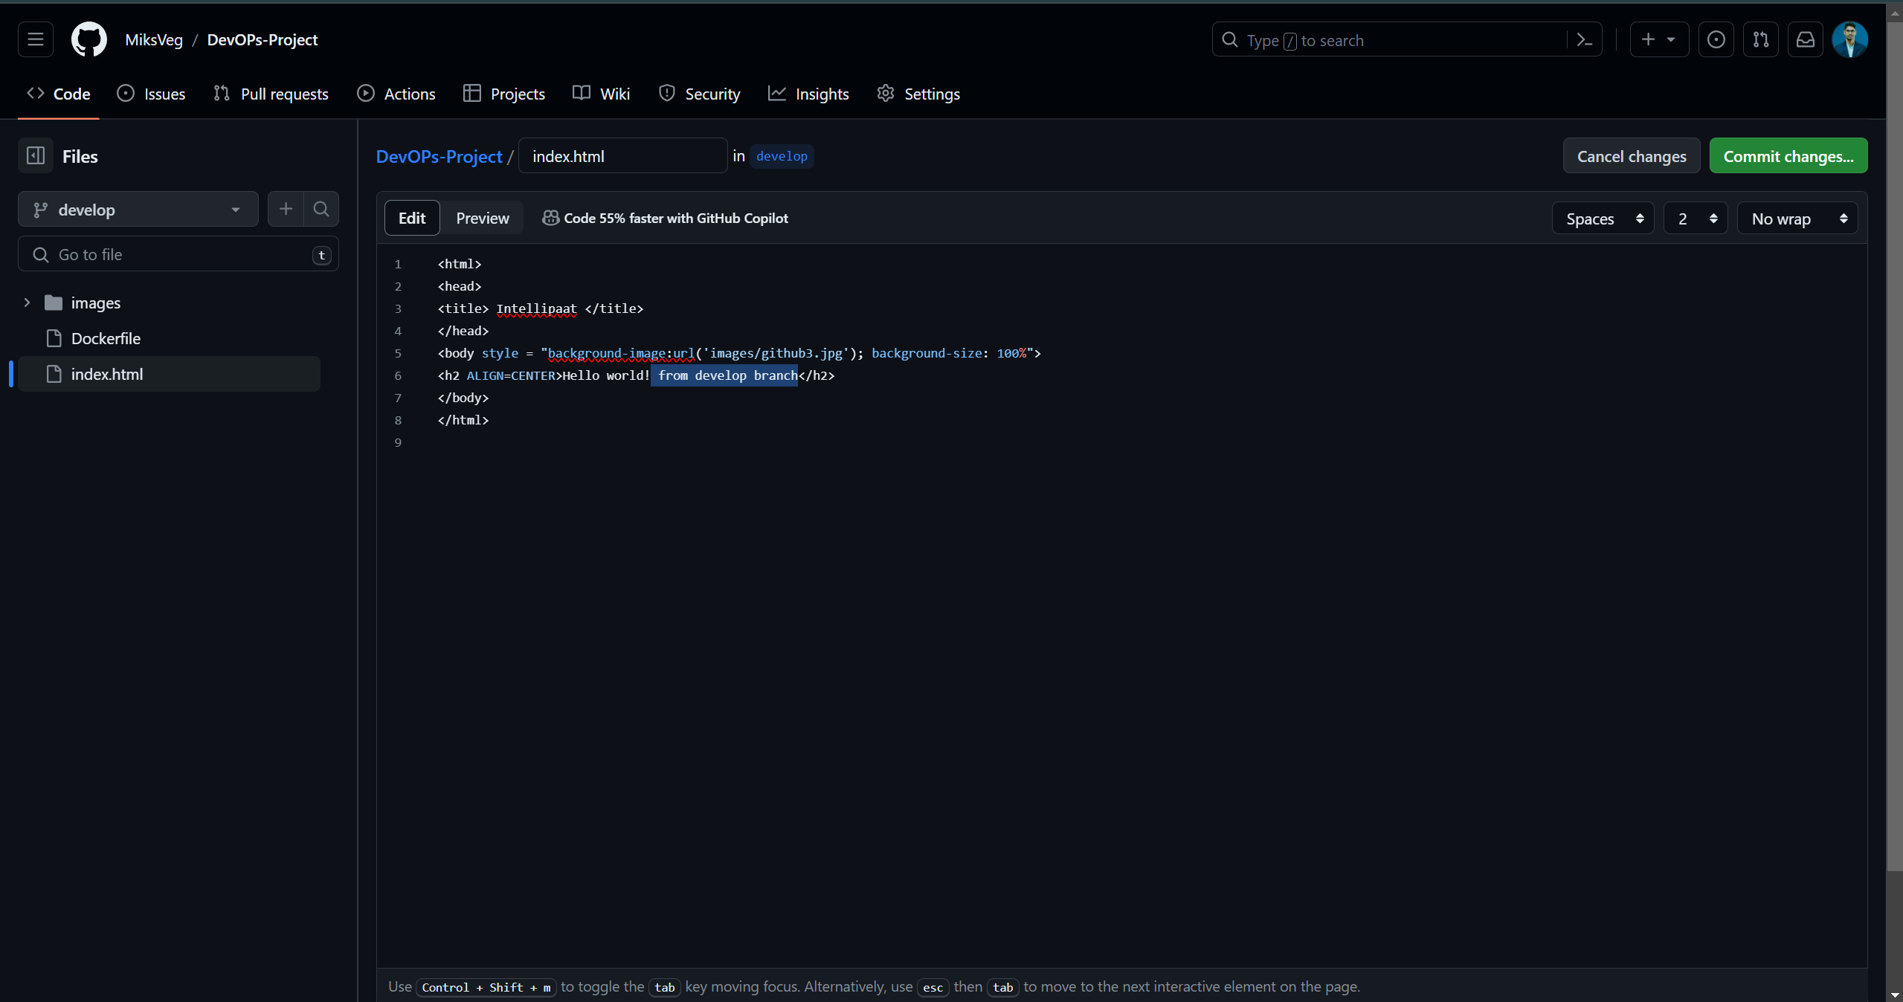



Committed a change in **develop branch**

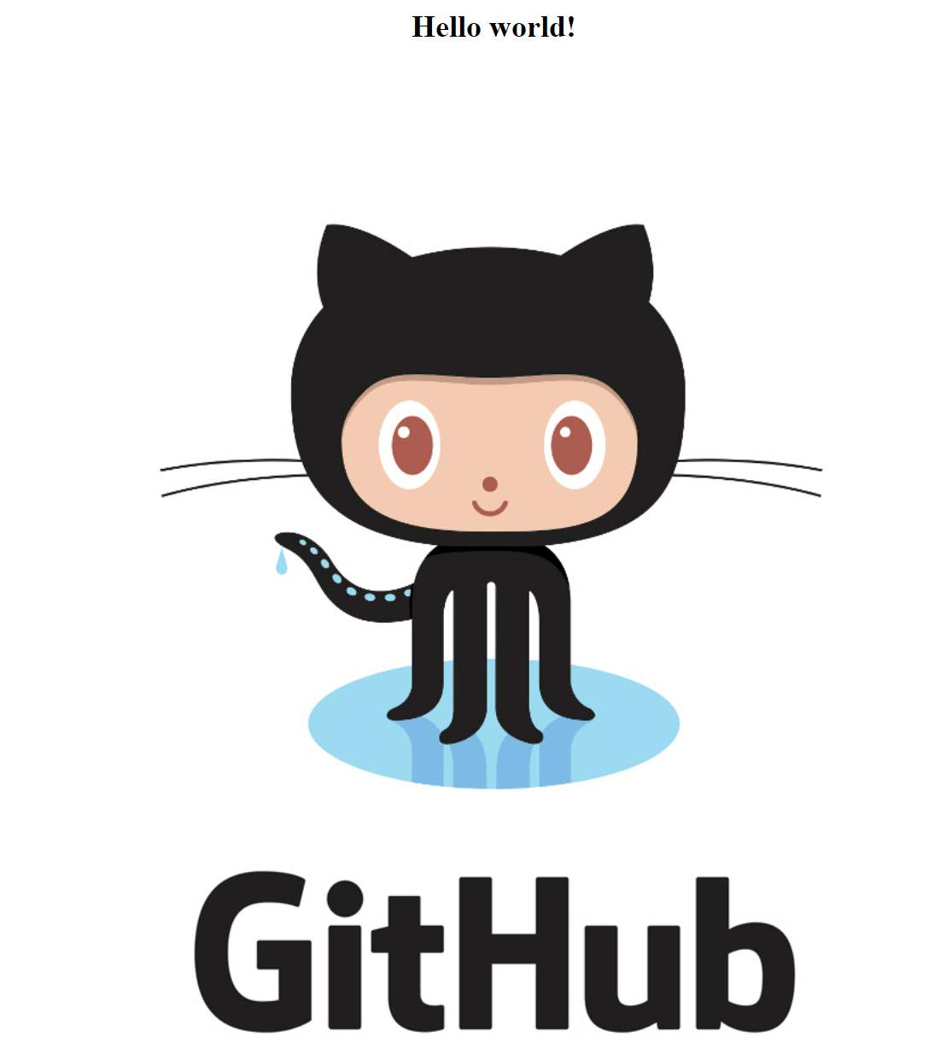



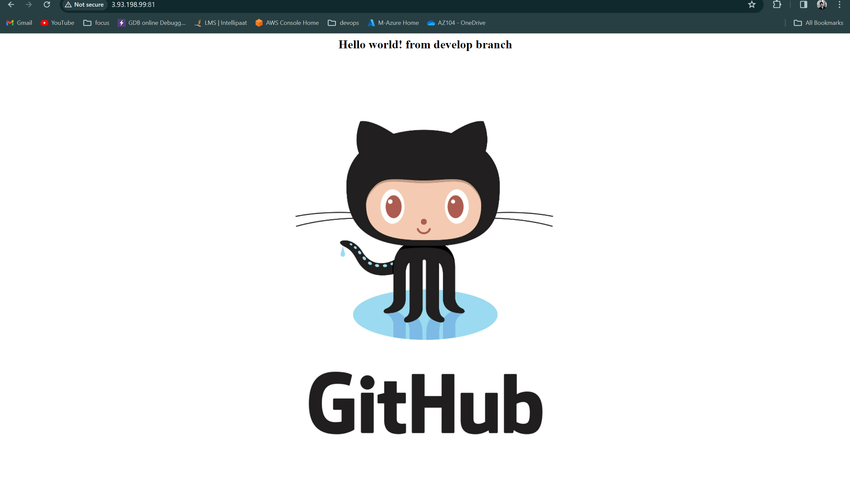

Automatically changed the code build when we commit changes in develop branch

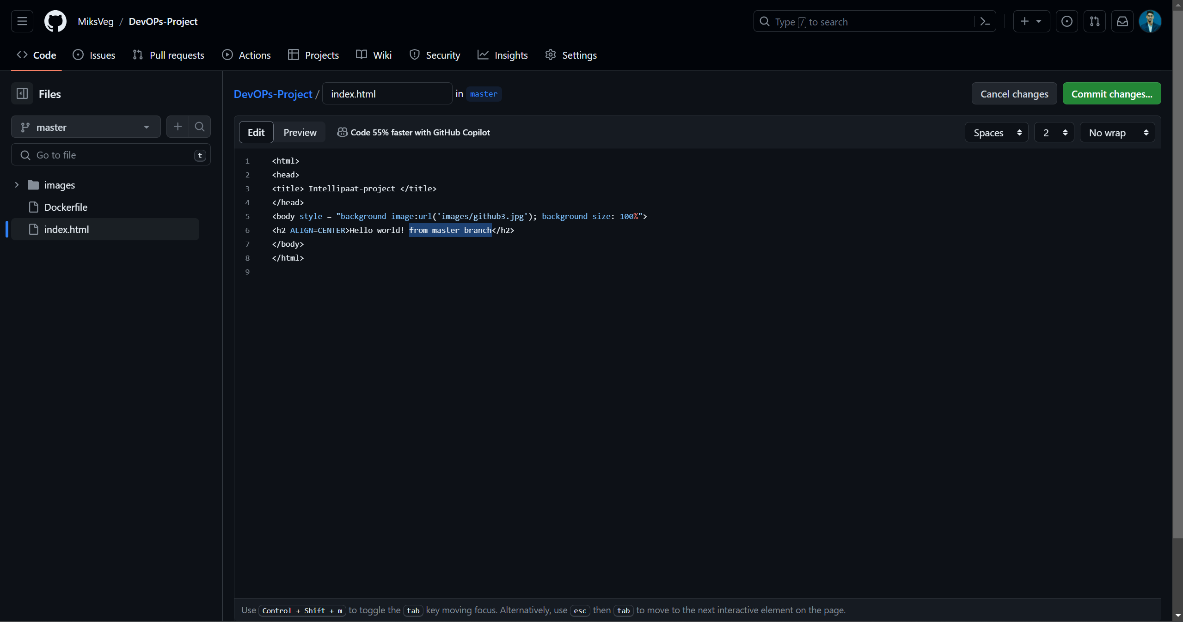

Committed a change in **master branch**



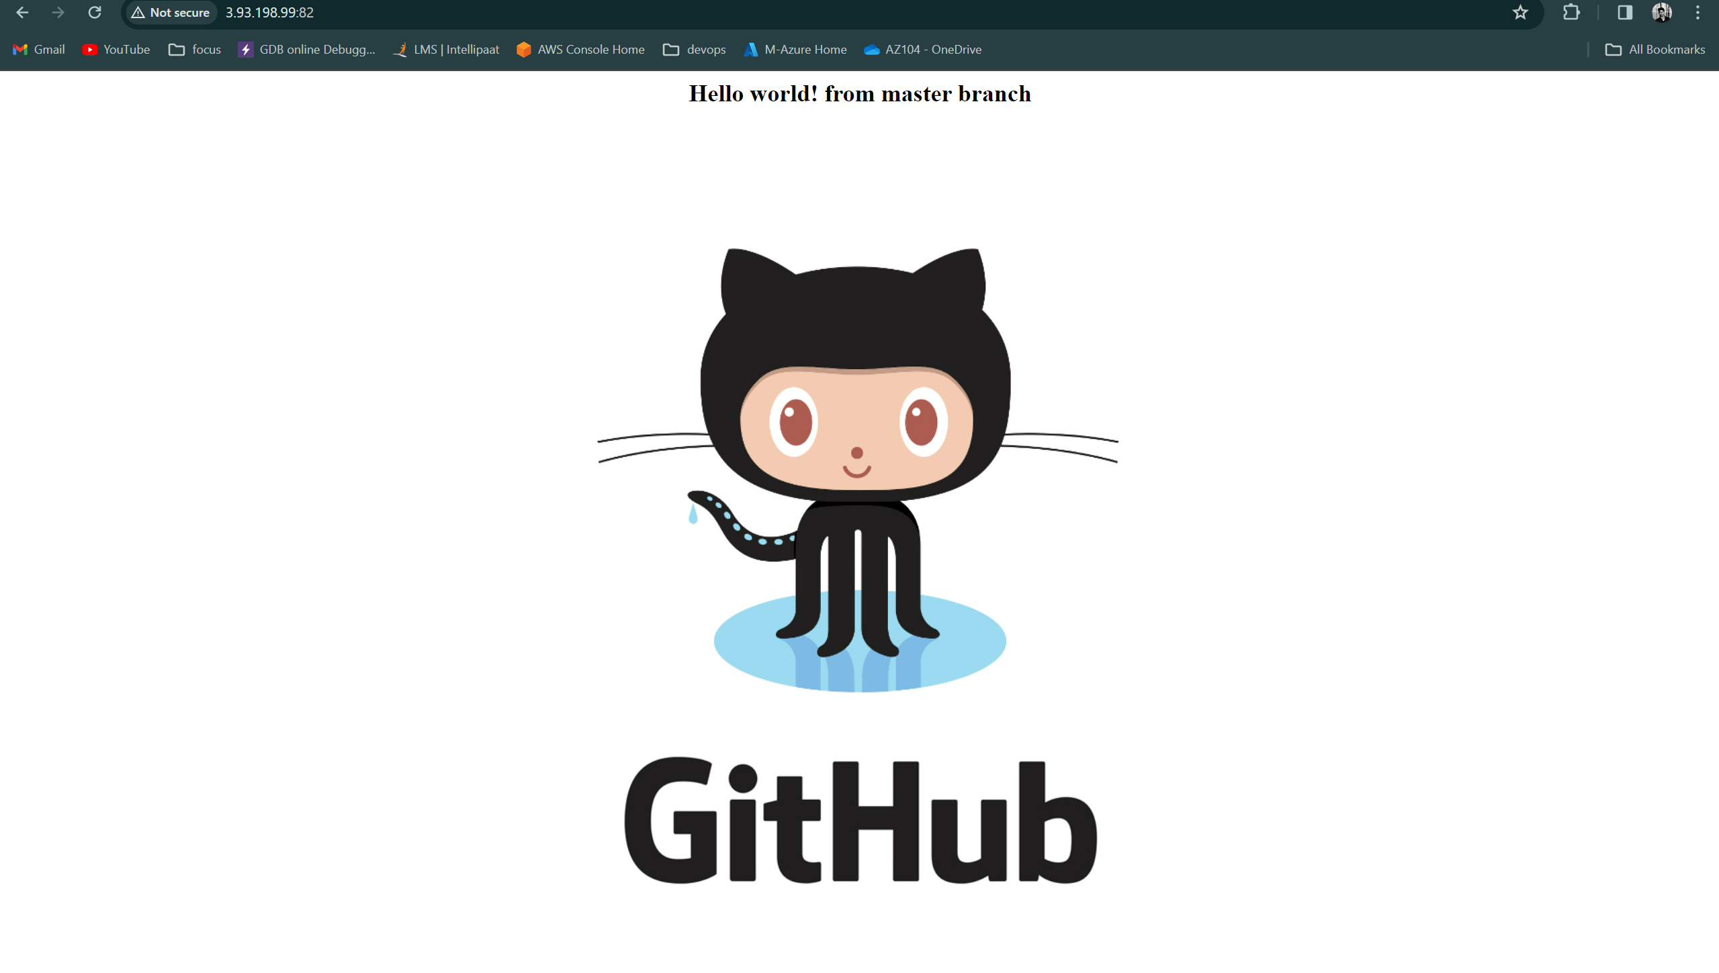 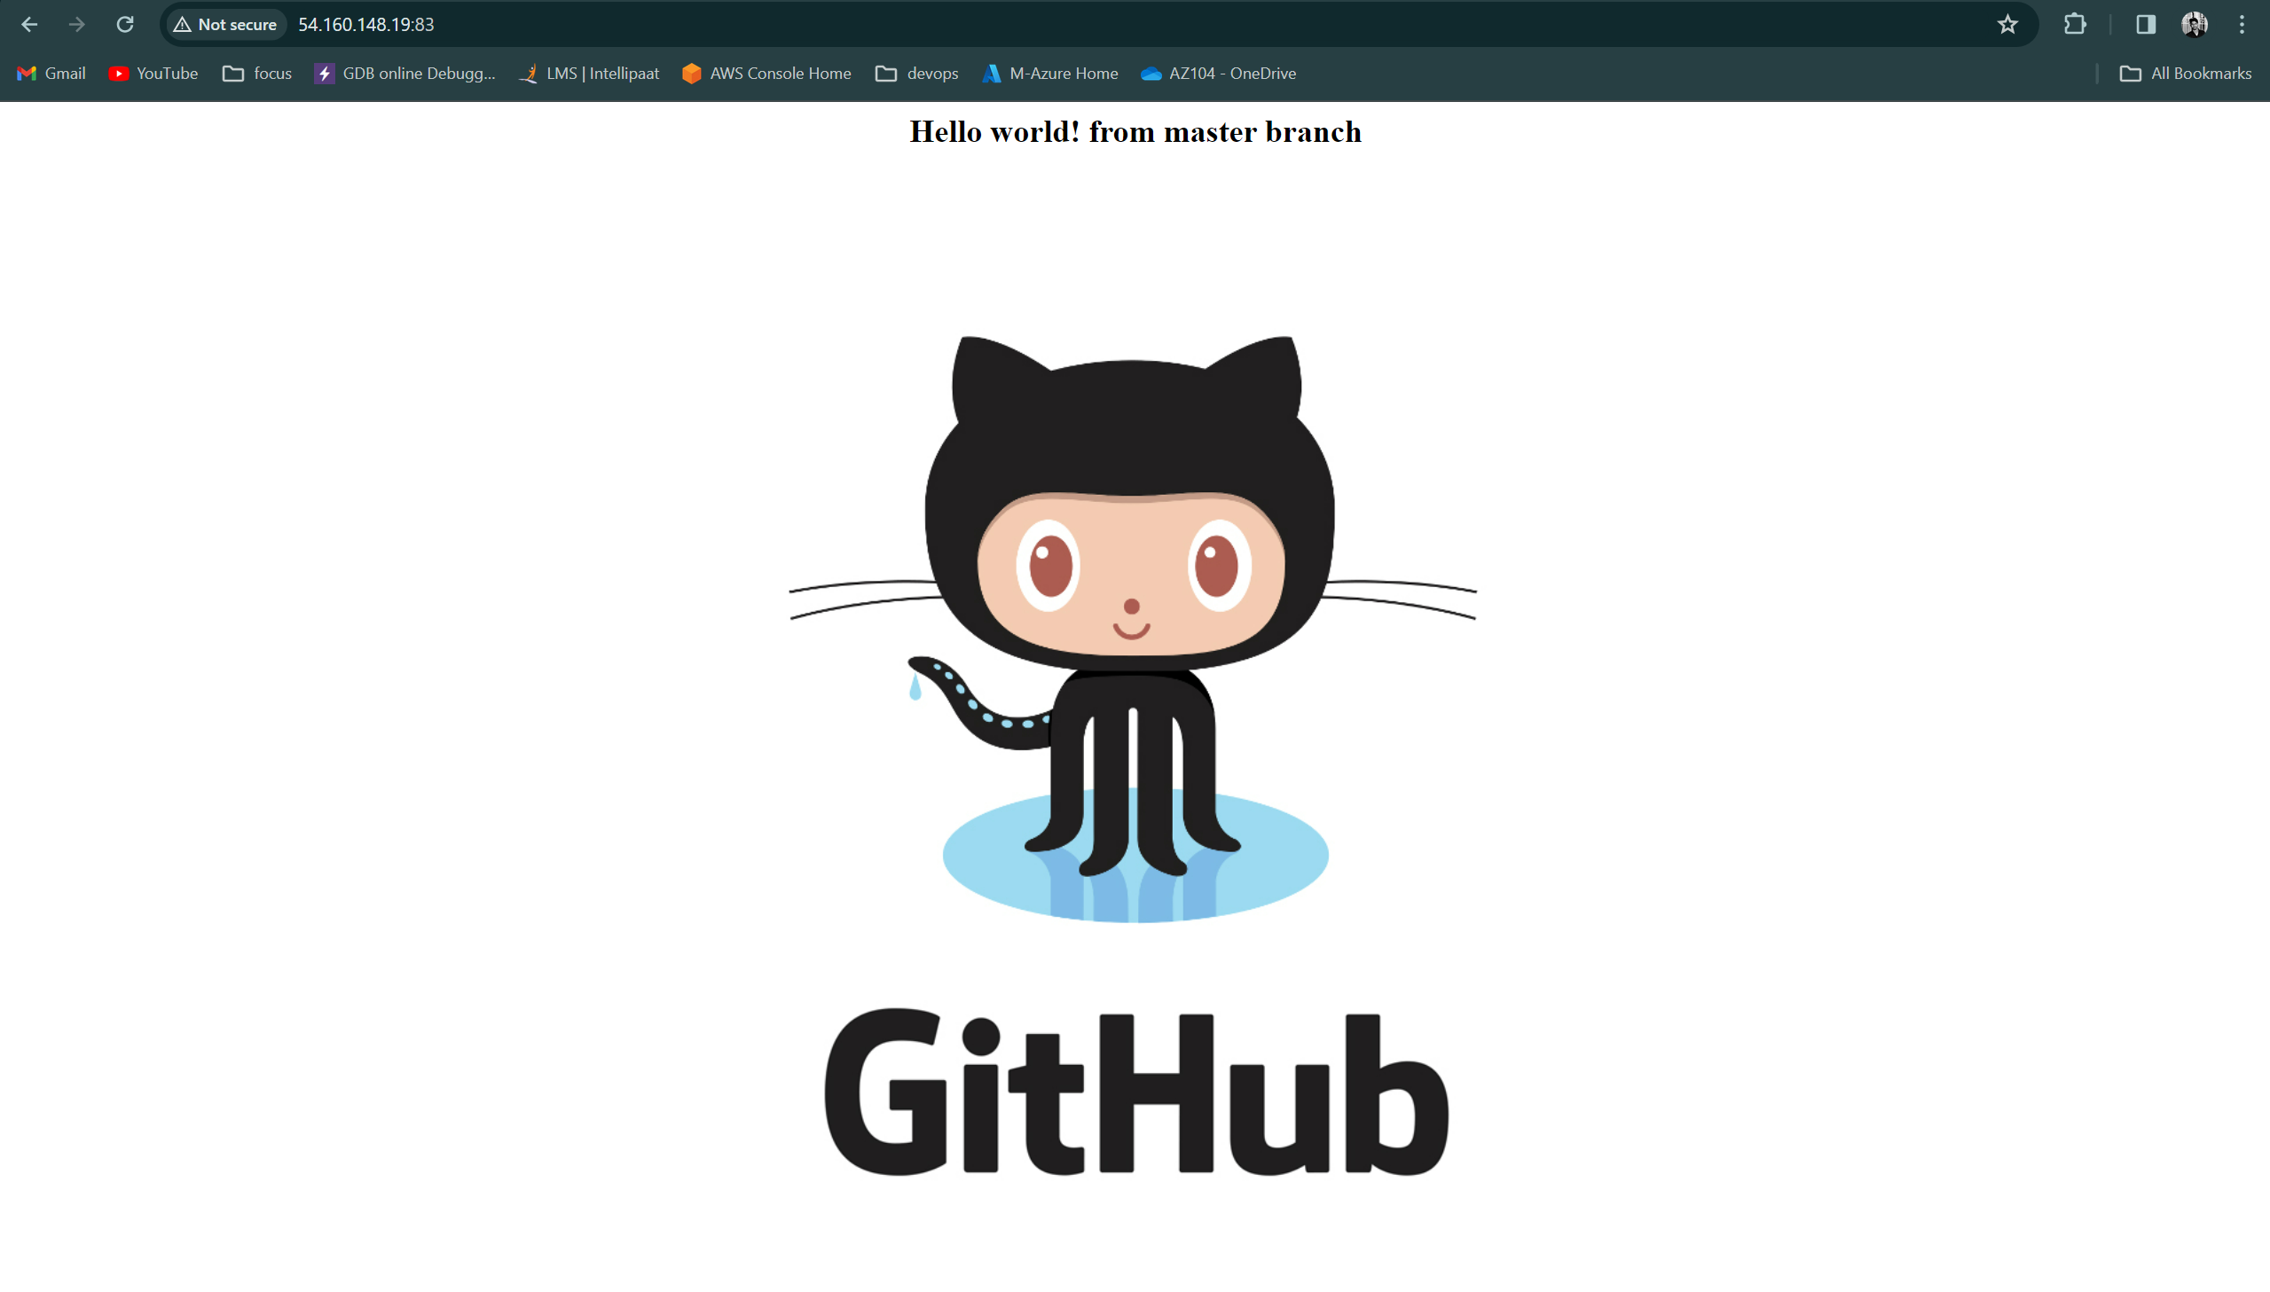



Automatically changed the code build when we commit changes in master branch

**…………………………………………………Complete of the Project………………………………………………**